THE LAURIE JEAN MATHIASON LANA DALE LEWIS
MEMORIAL MORATORIUM
OF ALL CHIROPRACTIC HIGHEST NECK MANIPULATIONS
ADJUSTMENTS

TABLE OF CONTENTS

PART | SUBJECT | PAGES
ONE | The Memorial Moratorium  February 2004 “Wellness Letter”.  Don’t agree to neck manipulation”. | 1-2
TWO | The Moratorium Protocol. | 3
THREE | Ten Basic Questions about Manipulation/adjustments of the highest neck area.  Why is it being done on babies?  Why is it being done on people who have no neck pain? | 5,6,7,8,9,10
FOUR | What this is about. Families who have lost a member and don’t ever want the same to happen to others.  What this is not about. Black-sheep, politics and a turf war between doctors and chiropractors. | 11,12  13
FIVE | The basic anatomy of the vertebral artery blood supply to the human brain. | 14,15,16,17
 | Drawing One: The Brain is like a flower with a bloom and a stem. Damage the stem and the flower may die. | 15
 | Drawing Two: The vulnerable vertebral artery, just at the point where highest neck manipulation takes place. | 16
 | Drawing Three: The dissection of a vertebral artery. | 17
SIX | How the neurological damage occurs. | 18
 | Drawing Four: Brain damage from moderate to death. | 18
 | Drawing Five: All the vital areas in the brain stem. | 19
 | Neurology textbook descriptions of some of the many  strokes that can result. | 20,21
SEVEN | The Scientific Evidence | 22-27
 | Death Reports. Guest editorial from a chiropractor | 24-27
EIGHT | The types of neck manipulations that are dangerous. | 28-29
 | Picture illustrations of neck manipulations. | 30

NINE | Expressions of Public Concern. The Media | 31
 | Editorial Issues | 32
TEN | The Arguments against a Moratorium.  Why is it necessary to stop a treatment if the risk is so rare? | 33-36
ELEVEN | Another argument against a Moratorium.  Is it not true that chiropractic neck manipulation is safer than neck surgery or taking anti-inflammatory medications? Why force people to do something more dangerous? | 37-38
TWELVE | Another argument against a Moratorium.  Chiropractic is self-regulated.  The Orthopractic guidelines. | 39-41
THIRTEEN | The “hole in one theory” The real reason why so many neck manipulations are being done.  The York University rejection of the Canadian Memorial Chiropractic College in Toronto. | 42-43
FOURTEEN | The issue of consent. | 44-46
FIFTEEN | Co-operation and research working together | 47-50
.

PART ONE

THE MEMORIAL

MORATORIUM

1.

LAURIE JEAN LANA DALE

MEMORIAL MORATORIUM

Named in memory of Laurie Jean Mathiason, Lana Dale Lewis, Donna Claire Fawcett, Renate Dora Labonte, Dr. Ron Grainger and others unnamed, whose families do not know the truth, or, who find it too painful to speak out.

We who remain in pain ask for the only gift we can give to others and for solace for ourselves in the knowledge that such unnecessary deaths will not happen to other families.

On behalf of Laurie Jean Mathiason, age 20 formerly of Saskatoon Saskatchewan, Lana Dale Lewis age 45 formerly of Toronto Ontario, Donna Claire Fawcett age 34 formerly of Barrie Ontario, Renate Dora Labonte age 40 years formerly of Guelph Ontario and Ron Grainger age 69 formerly of Calgary Alberta, daughters, mothers, sisters and a husband and father, we ask for the only thing we have left. We plead for those who have the authority, the government and the political leaders, to prevent what happened to our families from happening to others.

We also mention Krista A Bedenbaugh, age 24 of North Carolina and Wendy Dana Venegas, age 36 formerly of California, both deceased due to chiropractic neck manipulations and whose families ask that their names not be forgotten.

We ask in all their names for a moratorium on all chiropractic manipulations/adjustments of the highest neck area, skull to first vertebrae (atlas) and the second vertebrae (axis).
2.
THE MEMORIAL MORATORIUM

We call for the Provincial Ministers of Health to order “an immediate moratorium of ALL chiropractic highest neck manipulations/adjustments that involve the joints between the skull and the top two vertebrae in the neck”.

Our request is very specific and involves only two joints, one between the skull and the first vertebrae and the other between the first and seco

Scientific medicine has a long history of abandoning medications or medical procedures that prove not to be of acceptable risk-benefit. In our cases the result was death. In many hundreds of others, it the life long effect of stroke.

Whatever benefit there may be to manipulation therapy of the spinal column, we believe the chiropractic highest neck manipulation/adjustment of these specific joints is the thalidomide of manipulation therapy and must for now be placed under a moratorium.

We are not asking for a moratorium on any form of chiropractic treatments of the lower neck area. We are not asking for a moratorium on procedures in the lower neck involving massage or gentle mobilization.

We are not asking for a moratorium on chiropractic treatments for low back pain. We are not asking for a moratorium on the myriad of other therapies used by chiropractors.
-----------------------------------------------------------------------------------------------------
The University of California
February 2004

Consumer Guidelines Regarding Chiropractic

- “Don't agree to maintenance care involving repeat visits over long
periods. If your symptoms disappear, you don't need maintenance visits.
If they don't, you need some other kind of care, such as physical
therapy. You may, of course, need an ongoing exercise program that you
can carry out at home.”

- “Don't agree to neck manipulation.”

PART TWO

THE MORATORIUM

PROTOCOL

3.

THE MORATORIUM PROTOCOL

Once the moratorium is in place we ask the respective Ministers of Health to:

A: ESTABLISH A SCIENTIFIC ADVISORY COMMITTEE

with knowledge and experience in this field to prepare recommendations for the public. This scientific committee should include chiropractors, physiotherapists, neurologists, a neurology clinical stroke specialist, a neuropathologist, pediatricians, and 2 or 3 other scientific experts such as a statistician, epidemiologist and a medical educator/Dean of a medical school. The committee must include a family representative. A member of the committee would represent the Minister of Health.

B: This committee should be NON-POLITICAL.

Its members should consist of representatives of the respective bodies as indicated in number A.

C: The committee should be FUNDED

by government as an immediate discretionary grant.

D: This committee should, within a three-month period of time,

provide a preliminary or even a final report on this concern about chiropractic manipulations/adjustments of the highest neck area.

There is sufficient basic anatomical and physiological knowledge as well as an existing scientific database that can address the many questions in a timely fashion.

If all the questions cannot be answered, we believe enough of them can that will provide important safety guidelines.

E: This moratorium shall remain in effect

until the report of the Committee determines under what guidelines and conditions the Moratorium can be removed, limited or remain permanent.
5.

PART THREE

TEN BASIC QUESTIONS

ABOUT MANIPULATION
ADJUSTMENT
OF THE HIGHEST NECK AREA

Why is it being done on newborn babies?

Why is it being done on people who have no neck pain?

Why is it being done again and again on the same person without any objective measurement of improvement?

Etc. etc. etc.
6.

TEN BASIC QUESTIONS FOR
THE MORATORIUM COMMITEE TO CONSIDER

These questions are specific to chiropractic highest neck manipulations/adjustments that involve the joints between the skull and the top two vertebrae in the neck.

All of these questions are directly relevant to the strokes and deaths that have taken place in the families. There is no reason why a scientific advisory committee cannot answer these basic questions in a timely and responsible manner.

The time is over for long dissertations and sidetracks issues. Surely the parties on all sides can use existing scientific knowledge to answer these questions.

QUESTION ONE: What is the diagnosis being made?

If a medication is to be prescribed, a surgical procedure undertaken, or a manual therapy used, the first most basic question is, what is the diagnosis in the highest neck area of the patient for which the therapy is to be used?

Is the symptom pain? Is the diagnosis a restriction of motion? Is this restriction significant? Is it a normal variation found from one patient to the other?

Is the diagnosis a so-called, “chiropractic subluxation”? Do such subluxations actually exist?

QUESTION TWO: How is that diagnosis being made?

The scientific accuracy of a diagnosis is fundamental. We all rely on diagnostic methods such as the basic physical examination, blood tests, x-rays and pathology reports.

In this case, how is the diagnosis of pathology in the highest neck area being made?
Is there any significant reliability from one examiner to another as to the diagnosis of a restriction or a subluxation in the highest neck area?

QUESTION THREE: Would a chiropractic highest neck manipulation/adjustment effectively treat the diagnosis?

Once a diagnosis is made, a health care professional then goes about deciding on the best treatment for that diagnosis. Chiropractic highest neck manipulation was used to treat some of our family members for such things as migraine headaches, sinusitis, tailbone pain and low-neck pain. The valid question can be raised as to if such a “treatment” should have been used in the first place.

7.
QUESTION FOUR: If a treatment has the potential to cause extremely serious side effects, what controls exist to see that it is being used as a last resort?

A health care professional should always use the therapy that has the least potential to cause serious side effects. Stroke and death are the most serious of all side effects. Are other safer methods, such as watchful waiting, mild massage, or gentle mobilization being tried before a neck manipulation is done? Will the condition resolve without anything being done?

A narcotic medication is one example of many of a therapy that is “controlled” and only prescribed with great necessity. Should chiropractic highest neck manipulation become a restricted therapy used only as a last resort and done under controlled circumstances?

QUESTION FIVE: Is chiropractic highest neck manipulation being done for reasons that have no scientific merit? Is it being done as part of a philosophical belief system? Why is highest neck manipulation being done on patients who have no neck pain or any other complaint in that area? Why is it being done repeatedly again and again on the same patient, sometimes on every visit?

Laurie had no neck pain yet her neck was manipulated on the very first visit. Lana and Renate had migraine headaches, not neck pain. Ron had headaches and some neck pain, much worse after the final neck manipulations. Donna had mainly headaches as well as some neck pain.

On what valid evidence would a chiropractor conclude that highest neck manipulation could be used to treat these conditions? Acceptable scientific evidence is the only way to justify a therapy, especially one that can result in stroke and death.

Is chiropractic highest neck manipulation adjustment being used for non-scientific philosophical types of reasons? Why is it being done on newborn babies?

Many chiropractors claim that high-neck manipulations can be used to treat conditions like autism, ear infections, asthma, and even AIDS by correcting the elusive "vertebral subluxation". Is this of scientific merit?

Some chiropractors believe that there is some sort of “innate intelligence” existing in the spinal cord. They believe that manipulation of the highest neck area is “a hole in one treatment” The hole is the top of the spine where the brain stem forms the spinal cord which then passes through the skull and top two vertebrae to enter the vertebral column. They believe that highest neck manipulation will then release the innate intelligence of the spinal cord.

8.

Is this the reason why highest neck manipulations are performed on infants and children? Is this the real reason it is repeatedly done to the same patient? Is this the real reason it is performed on people who have no neck pain or symptoms in the highest neck area?

QUESTION SIX: What are the various types of techniques being used to treat the diagnosis made in the highest neck area?

Each prescription medication is unique in terms of its pharmacological properties. The same can be said for the many manual therapy techniques used. Some techniques are very gentle and don’t involve head and neck rotation while others involve a high velocity movement with a considerable amount of head and neck rotation.

Is the technique being used appropriate for the complaint of the patient? If the complaint is a minor pain, will the technique itself be mild?

If the diagnosis being made is a philosophical one, such as a subluxation, will the technique be different?

QUESTION SEVEN: Are some techniques safe and others more dangerous?

The anatomy of the vertebral artery in the neck and the scientific literature indicate that the most dangerous types of neck manipulations are those that involve rotation of the high neck. Physiotherapists who practice manipulation therapy have banned all high neck manipulation involving extension and rotation. Should chiropractors be doing the same?

CHIROPRACTORS HAVE EXPRESSED CONCERN
ABOUT CERTAIN TECHNIQUES.

“Because it is currently impossible to identify patients at risk of having a dissected artery with standard in-office examination, procedures, rotational manipulation of the upper cervical spine should be abandoned by all practitioners, and school should remove such techniques from the curriculums” (Chiropractor Thomas C. Michaud. Journal of Manipulative Physiology Therapeutics. 2002; 25:472-83)

And

“It is my understanding that Laurie Jean Mathiason presented to the chiropractor for care of a lower back/tailbone injury for which she was, at least partially, treated with cervical adjustments. Is it possible that she would still be alive today had she sought treatment from a chiropractor who did not utilize full-spine treatment for a low back compliant? Or a non-manipulative technique?”

9.

“Despite publications that suggest that neck manipulation involving rotation cannot yet be identified as a causative factor, other authors appear to concur with Reggars et al on limiting or eliminating rotation during manipulation in order to minimize risk. If rotation has been suggested as a risk, this approach is appropriate until evidence suggests that it is either safe or clinically necessary.”

Chiropractor H. Michael Carstensen. St. John’s Newfoundland. Guest Editorial. Lessons from Laurie Jean Mathiason. The obligation of Risk Management. Journal Australian Chiropractic and Osteopathy. 2003, 11(1): 17-19

QUESTION EIGHT: How will manual therapy treatments be regulated to ensure safety and scientific values?

The safety and effectiveness of prescription medications are under the control of the Federal Government of Canada via the Health Protection Branch. The same is true for medical devices. Both these agencies are independent of the health care regulatory body of the medical profession.

Once a prescription is approved, then the basis for its use resides in the scientific training and clinical judgment of the physician. The same is true for manual therapists be they chiropractors, physiotherapists or physicians.

If a health care professional undertakes a therapy in a negligent and dangerous manner, then the process could involve the regulatory body of that profession.

If however, the therapy is not being properly regulated by the Regulatory body and if the therapy is an issue of general health concern, especially if, as manual therapy does, more than one professional body is practicing the therapy, then the Minister of Health of the Province would be the authority to investigate and intervene.

QUESTION NINE: Which specific guidelines could the Moratorium Committee develop to ensure safety and effectiveness?

Any medication, surgical procedure or physical therapy treatment that has clearly been proven to cause stroke and death, no matter how rare that complication may be, must be used with great caution. The hallmarks of this caution are:

1. The disease is serious enough to warrant the treatment.

2. There is really no other safer and more effective choice.

3. That there is clear and substantial evidence that the treatment is effective.

10.

4. That there is some objective manner of demonstrating the clinical improvement of the patient.

5. That there is some way to screen patients so that those at risk will not be subject to the risk.

6. That if a complication does arise, it is quickly diagnosed.

7. That a treatment exists so that the complications can be treated.

We sincerely believe that such a scientific review will be of immense benefit to all practitioners of spinal manipulation therapy. All chiropractors interested in the safe and scientific practice of such therapy would we expect full endorse such an examination.

In the past when health care professionals such as neurologists and pediatricians have questioned the safety of chiropractic neck manipulation the response from chiropractic authorities has been to call these valid questions, “scare tactics” and “fear mongering” and even to threaten legal action against those who sincerely express their concerns.

It is not time for the chiropractic profession to move beyond such attacks and to address the scientific issues at hand?

QUESTION TEN
What is the best immediate way to stop strokes and deaths?

The best immediate way to stop all strokes and deaths is to have a Moratorium on all chiropractic highest neck manipulations/adjustments. It is clear that this specific area of the highest neck is the most dangerous place for the artery to be damaged and for pathology to occur.

It appears clear that those manipulations that involve some degree of head rotation and a sudden thrust are the type of neck manipulations that are most dangerous. Yet, we also have case reports of children with an underlying brain tumor or an adult with some inherent anomaly of the circulatory system that will put that at risk for other milder types of highest neck manipulation.

We don’t really know and until we do, we have to err on the side of safety.

11.

PART FOUR

WHAT THIS IS ABOUT.

WHAT THIS IS NOT ABOUT.

This is about families who have lost a family member and don’t want this to happen to others.

This is about having all the professions work together in a co-operative manner to resolve a valid public health concern.

This is about legislators using common sense, good judgment and scientific evidence in their decision-making.

This is not about a conspiracy from the medical profession to control chiropractic.

This is not about denying members of the public from seeking care from whomever they wish.

This is not about painting with a wide brush to condemn an entire profession.

12.

WHAT THIS IS ABOUT

This is about families who have lost a family member and want to know why?

This is about families who have a member who has had a stroke and want to know why?

This is about people who had minor non-threatening medical concerns and yet ended up with a stroke or dead.

This is about having all the professions work together in a co-operative manner to resolve a valid public health concern.

This is about using science as the valid guideline to provide safe and effective care.

This is about neck manipulation as it is being taught and practiced by a very significant percentage of chiropractors.

This is about stopping a treatment method that may be of no proven benefit for the large number of the reasons for which it is being used. Why is it being done on newborn babies and young children? Why is it being done to treat ear infections, A.I.D.S. or low back pain?

This is about keeping what is of value in manual therapy so that people are not denied a treatment method that may be of value.

This is about making sure that people do not have to resort to other therapies that may be more dangerous than various forms of neck manipulation.

This is about being sure that those who regulate the profession of chiropractic for the public good do live up to their responsibilities.

This is about something that is not rare and is happening to young people who are otherwise healthy and most often in the prime of their lives.

This is about political leaders using common sense, good judgment and scientific evidence in their decision-making.

This is about the media using common sense, good judgment and scientific evidence in their reporting to the public.

This is about all parties favoring caution as the first priority.

13.

WHAT THIS IS NOT ABOUT

This is not about a conspiracy from the medical profession to control chiropractic.

This is not a turf war between doctors and chiropractors.

This is not about blaming physicians for medical errors. Every therapy must stand on its own merits. Whatever is harmful practiced by any health care provider should be removed.

This is not about denying members of the public from seeking care from whomever they wish.

This is not about black sheep who exist in every profession.

This is not about practices that are no longer taught.

This is not about painting with a wide brush to condemn an entire profession.

This is not about using legal threats to try to intimidate those who express valid personal as well as scientific questions. Valid therapies are decided by science and not by lawyers.

This is not about something that is rare, especially to those who have suffered.

This is not about denying people safe and scientific manual therapy.

This is not about forcing people to resort to other therapies that may be more dangerous.

This should not be about legislators who chose politics above public health and safety.
14.

PART FIVE

THE BASIC ANATOMY
OF THE VERTEBRAL ARTERY
BLOOD SUPPLY TO
THE HUMAN BRAIN.

The vertebral arteries and the basilar artery they form are the essential blood supply to this most vital part of the brain.

The vertebral artery (so called because it travels up in the wings of the neck vertebral bones) is completely surrounded by the ring of bone in the area. If the neck is rotated enough, the artery will be affected.

If any of the layers of the artery separate between each other, we call this a “dissection”. The word “dissection” comes from the anatomical word, to “separate.”

The wide variety of vital activity in the brain stem and the cerebellum accounts for the more than 20 different kinds of strokes that can happen from a chiropractic neck manipulation.
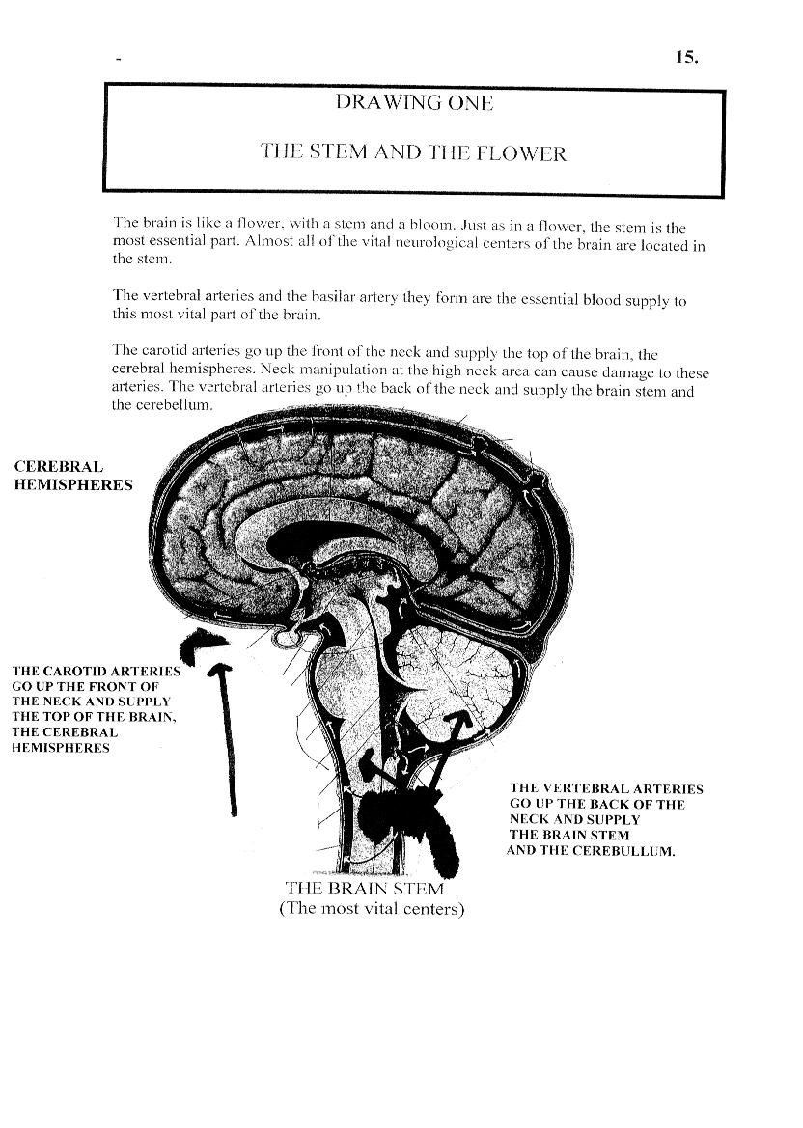

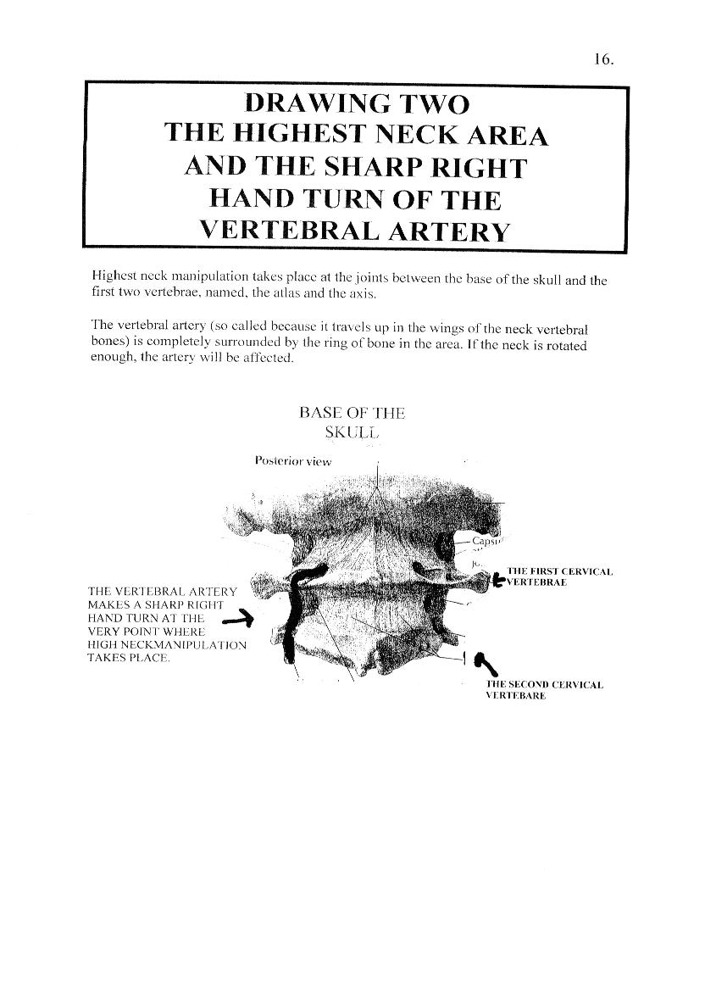

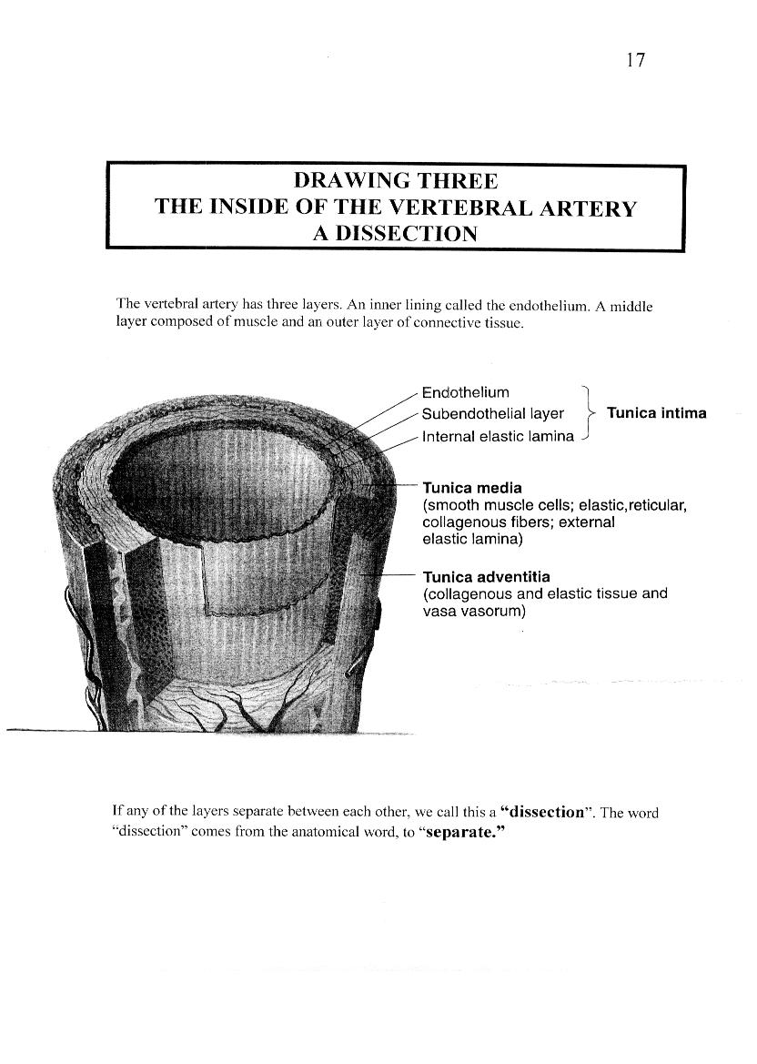
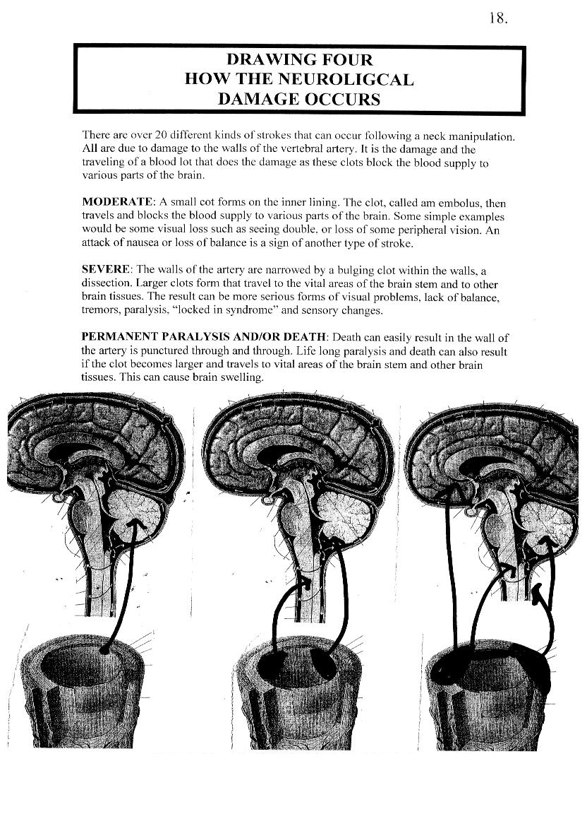

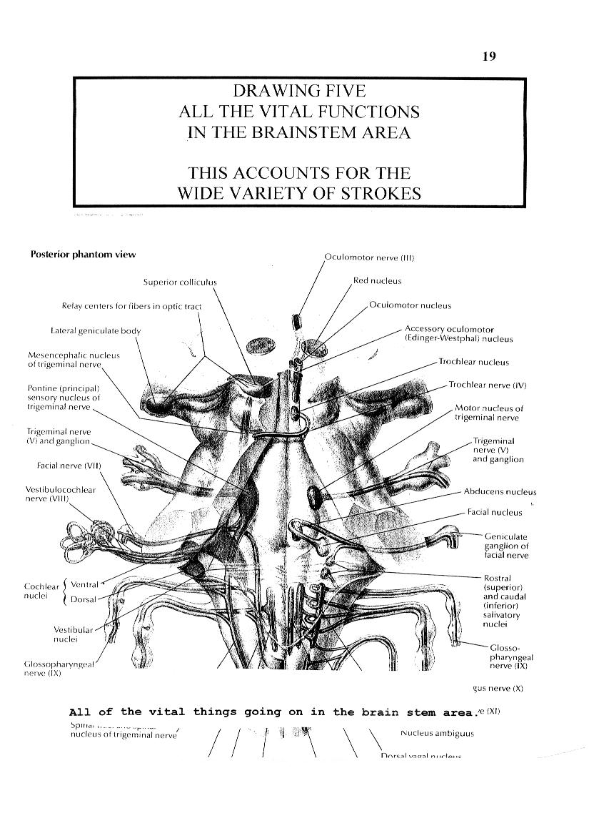

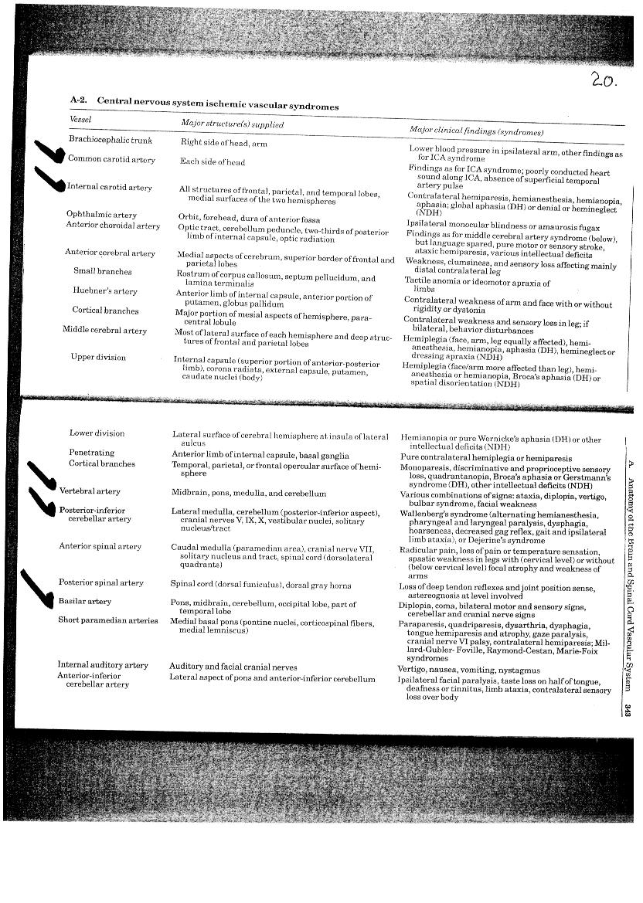
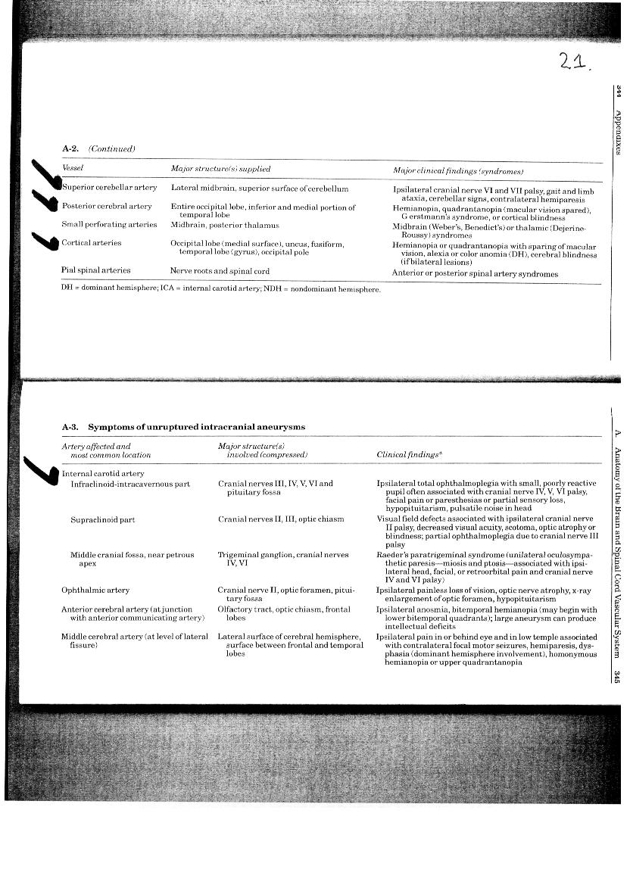

22

PART SEVEN
THE SCIENTIFIC EVIDENCE
HIGHEST NECK MANIPULATION
MISCHIEF, CHAOS, STROKE, DEATH

“Chaos” from neck manipulation has been reported for over 2,000 years.

Since the very inception of modern scientific reporting, over 60 years ago, stroke and death due to highest neck manipulation has been reported.

The published scientific literature is the tip of the iceberg as to what is happening below.

The Mayo Clinic, The Journal of Forensic Science, The New England Journal of Medicine and the Journal of Emergency Medicine are a few of the respected Journals that have published articles on the neurological complications of chiropractic neck manipulation.

Canada, the United States, Denmark, Germany, Italy, Australia, Japan and Switzerland are a few of the countries from which scientific articles have been published.

23

PART SEVEN
THE SCIENTIFIC EVIDENCE

Over 2,000 years ago, healers noticed that people became ill, had a fever and their joints would swell. Though they did not know that this was due to a common bacterium, causing the disease rheumatic fever, they did know that when they pressed on the joint the fever would soon subside and the swelling would resolve. The patient appeared to have recovered. Bonesetting became a tradition.

The healers also discovered that when they did manipulate the joint, a loud popping sound, actually nitrous oxide gas could be heard. Producing that sounds became the mantra of “bone-setters”. The best joint they found to produce it was at the top of the neck.

It was not long before problems arose. Hippocrates, over 2000 years ago commented that cracking the neck may “make much mischief”. One hundred and fifty years ago, James Paget a British physician noted that, “Chaos of this kind is a frequent occurrence”.

Daniel David Palmer founded chiropractic in 1895 after he produced just such a crack on the neck of a client. Chiropractic was born with neck manipulation and has remained faithful to it ever since. The Canadian Memorial Chiropractic College in Toronto is a memorial to Palmer.

Published reports in the scientific literature allow us to stand on the very tip of the iceberg largely unaware of the reality below. Most scientisits never take the time and effort requried to report what they have found. Medical Journals refuse the great majority of submissions. Thus the overall picture of the true incidence and seriousness of an issue is superficiously reflected by the medical database resource.

Yet the scientific literature does provide some insghts. How many well respected scientific journals have addressed the issue? How consistent year in and year out have reports been made? How many different countries have reported on the issue? What is the degree of specialization of those scientists publishing these studies? What is the range of problems reported?

In regard to the issue of highest neck manipulation, occipital to cervical one (atlas vertebrae) and cervical one to cervical two (axis vertebrae) studies have been reported in numerous scientific journals including, The Journal of Forensic Science, The Journal of Clinical Pathology, The Journal of the American Medical Association, the Journal of the Canadian Medical Association, the British Medical Journal, the journals “Neurology: “Stroke”, “Lancet”, “Pediatrics”, The New England Journal of Medicine, The American Journal of Emergency Medicine, etc. etc.

24

The range of interest of these Journals include neurology, neuroradiology, pathology, forensic sciences, legal publications, family medicine, rehabilitation medicine, ophthalmology, audiology etc. etc. Numerous prestigious hospitals and Universities across the world have reported cases including the Mayo Clinic, Johns Hopkins Hospital, the Claude Bernard Hospital, the Veterans Administration Medical center in California, etc. etc.

The issue has been reported from Canada, the United States, Denmark, Germany, Italy, Australia, Japan, England, Canada, China, South Africa, Ireland, New Zealand, Switzerland, etc. etc. indeed worldwide.

The issue has also been reported on since the very inception of modern medical index medicus over 60 years ago. The results are consistent. The medical consequences of neck manipulation run the range from simple spells of nausea to the Locked-In Syndrome to death. It happens in all ages, from babies to people in their 80’s. It most commonly happens in young adults in the prime of their lives.

SCIENTIFIC LITERATURE
AND CASE REPORTS
DEATH CASES DUE TO HIGHEST NECK MANIPULATION.

1. 1934: Foster versus Thornton. Malpractice. J.A.M.A. 1934:103(16): 1260 female patient. Cerebral hemorrhage. Death two later.

2. 1947: Pratt-Thomas HR, Berger KE. J.A.M.A. 1947; 133 (9):600-3. Male patient. 34 years. Death. 24 hours after neck manipulation.

3. 1955: York v. Daniels. J.A.M.A. 1955; 159 (8):809. Death 8 hours after neck manipulation.

4. 1956: Ford FR, Clark D. Bulletin. Johns Hopkins Hospital: 1956; 98: 37-42. Male patient age 37. Death 3 days after neck manipulation.

5. 1962: Smith RA. Estridge MN. J.A.M.A.1962; 182(5):528-31. Death.

6. 1963: Roche L, Collin M, De Rougemont J, Ann Med Leg 1963; 43: 232-5
Death. 3 days after neck manipulation. Cerebellar and brainstem

7. 1972: Lorenz R, Vogelsang HG. Deutsche Med Wochenschrift 1972; 97: 36-43. Death. 58 days after neck manipulation.

8. 1973: Schmitt HP, Tamaska L. Z Rechtsmedizin 1973; 73: Death 3 hours after.
301-8.

25.

9. 1975: Kipp W. Todlicher Eberhard Karls Universtitaet 1975;39. Death three days after neck manipulation.

10. 1976: Hensell V. Med Welt 1976; 27 (14): 656-8. Death 24 hours later.

11. 1976: Goodbody RA. J Clin Pathol 1976; 29 (1): 86-7. Death 2 days after neck manipulation.

12. 1976: Schmitt HP.Schweizer Archiv fur Neurologie Neurochirurgie und Psychiatrie 119: 363-9. Death 4 weeks later.

13. 1978: Nyberg-Hanser R, Loken AC, Tenstad O.Journal Neurolgy 1978; 218: 97-105. Death after five years in a coma.

14. 1980: Krueger BR, Okazaki H. Mayo Clinic Proceedings.55:322-232. 1980
Vertebral-basilar distribution infarction following chiropractic cervical manipulation. Death 2 days after neck manipulation.

15. 1981: Sherman DG, Hart RG, Easton JD. Abrupt change in head position and
cerebral infarction. Stroke 1981; 12 (1): 2-6. Death 4 days after neck manipulation.

16. 1982: Meyermann R. Moglichkeiten einer schadigung der arteria vertebralis.
Manuelle Medizin 1982; 20: 105-14. Death a few hours later.

17. 1983: Gutmann G. Gutmann G. Verletzungen der arteria vertebralis durch manuelle therapie. Manuelle Medizin 1983; 21: 2-14.Verletzungen der arteria vertebralis durch manuelle therapie. Death after neck manipulation.

18. 1983 Pamela F, Beaugerie L, Couturier M et al. Syndrome de differentiation motrice par thrombose du tronc basilaire apres manipulation vertebrale. Presse Medicale 1983; 12 (24): 1548. Death six weeks after neck manipulation.

19. 1983: Ali Cherif A, Delpuech F, Habib M, Salamon G, Khalil R. Thrombose vertebro-basilaire apres manipulation du rachis cervical. Annales de Medecine Physique 1983; 25: 459-65. A propos de deux . Death eleven days after neck manipulation.

20. 1984: Zak SM, Carmody RF. Case report and review of the literature.
Arizona Medical 1984; 41(5): 333-7. Cerebellar infarction from chiropractic neck manipulation: Death 11 days later.

21. 1984: Nielsen AA. Cerebrovaskulaere insulter forarsaget af manipulation af
columna cervicalis. Ugeskr Lager 1984 (22 Oct); 3267-70. Death. 3 hours after.

22. 1985: Modde PJ. Chiropractic Malpractice. Columbia, Maryland: Hanrow Press
269-70, 273-5, 311-8, 322-3, 329-31, 334-7. Female age 26. Death hours after.

26

23. 1987: Jentzen JM, Amatuzio J, Peterson GF J Forensic Science 1987; 32 (4): 1089-94. Complications of cervical manipulation: Death

24. 1987: Terrett AGJ. Vascular accidents from cervical spine manipulation: J Aust Chiro Assoc 1987; 17 (1): 15-24. Death. 3 days after.

25. 1987: Bolton SP. Vascular accidents. J Aust Chiro Assoc 1987; 17 (2): 75. Death 18 hours after.

26. 1987: Sherman MR, Smialek JE, Zane WE. Archives of Pathology and Laboratory Medicine. 111:851-853(9)1987. Death after 52 hours

27. 1987: Dunne DW Jp Conacher GN, Khangure M.Journal of Neurology, Neurosurgery and Psychiatry. 50:349-353. Death 3 days after.

28. 1987: Ontario. Donna Claire Fawcett. Age 34 years. Death after several months in a coma. Family declaration. Unpublished.

29.. 1989: Mas JL, Henin D, Bousser MG, Chain F. Hauw JJ. Dissecting aneurysm of the vertebral artery. Neurology 1989; 39: 512-515, 1989. Death 16 hours after.

30. 1990: Raskind R, North CM.Vertebral artery injuries following chiropractic cervical spine manipulation.Angiology 1990; 41 (6):445-52. Death 8 hours after.

31. 1992: Sullivan EC. Brain stem stroke syndromes from cervical adjustments: Report on five cases. Journal Chiropractic Research & Clinical investigation 1992; 8 (1): 12-16. Death 18 hours after.

32. 1993: Badenbaugh K. Wisconsin death following chiropractic neck manipulation. Case report. Unpublished.

33. 1995 Quebec. Canadian Stroke Consortium. Female age 34. Death a few hours after.

34, 1995: Rosa A, Klein J, Penisson-Besnier I, Dubas E Hematome cerebelleux apres manipulations cervicales chez on homnie de 48 ans. Rev Neurol (Paris) 1995; 151 (12): 739-43. Death 1 month later.

35. 1995: Peters M, Bohl J,Thonike I, Dissection of the internal carotid artery after chiropractic manipulation of the neck. Neurology 1995; 45: 2284-6. Female age 29. Death 3 months later.

36. 1997: Canadian Stroke Consortium. Retrospective report. Case report 105-01-UU. 40 year old female. Death ten days after chiropractic neck manipulation. Not published.

27

37. 1997: Canadian Stroke Consortium. Case number 120-13. Retrospective study. 75-year-old female. Died after neck manipulation. Not published.

38. 1998: Opeskin K, Burke MP: Vertebral artery trauma. American Journal of Forensic Medicine and Pathology. 19:1206-217. 1998. Death 3 days after neck manipulation. Final diagnosis unclear.

39. 1999: Canadian Stroke Consortium. Retrospective Study. Case Number 1180-01. 87 year old male. Death 10 days after neck manipulation. Not published.

40. 1997 Terrett AGJ. A case of death following vertebrobasilar stroke (VBS) attributed to spinal manipulation therapy. The Australian Chiropractor 1997 (Dec); 16-17

41. 1998: Macaulay. R. Neuropathologist. Inquest testimony. Laurie Jean Mathiason. Saskatoon. Saskatchewan.

42. 1999: Office of the Medical Examiner. San Diego, California. Wendy Venegas. 34-year-old death. Autopsy report available.

43. Lana Dale Lewis. Toronto. Coroner Jury verdict.

28.

PART EIGHT
THE VARIOUS TYPES OF NECK MANIPULATIONS
ROTATION, EXTENSION, THRUST

The basic anatomy of the body, the clinical findings of neurologists, and the diagnosis made on radiology examination and at times the final pathology results, clearly point to the following.

First, the most dangerous area for a neck manipulation to be done is the highest neck area in the joints between the base of the skull and the two top vertebrae.

Second, any movement involving rotation of the highest neck, such as holding the face and rotating the head are far more likely to cause stroke and death than manipulations in which there is no rotation.

That being said, there are instances where it may be possible for any type of highest neck manipulation to cause a stroke. This would include patients on anti-coagulants, children and adults who have a tumor growing in the spinal cord or patients, estimated to be as high as one to four percent of the population, who have anomalies of the vertebral artery blood supply. There have been several documented cases of stroke in young children who had underlying spinal cord tumors who became paralyzed after a high neck manipulation. This manipulation need not have been too severe to cause such a consequence.

Another area of concern is elderly people have had a spinal fusion or disk repair surgery.

Third, that the combination of neck rotation with the head held in extension, that is the chin upright and the neck pushed forward, is the most dangerous. This is sometimes called a “Master Cervical. This type of highest neck manipulation is completely banned by physiotherapists who do manual therapy.

Fourth, that high velocity thrust type of highest neck manipulations are the most dangerous. These are sometimes called, “Master Cervical” manipulations.

29
NOT ALL NECK MANIPULATIONS ARE THE SAME.

The recommendations of a manual therapist can run the range from doing nothing beyond an examination, weight loss, cold compresses, mild exercises, posture recommendations, gentle massage, and gentle mobilization of the muscles, gentle manipulations and finally more forceful manipulations
.
Manipulations can run the range from being gently done in a very limited range of motion to very forceful. The head can be held bent forward, which is called flexion, or it can be held backwards which is called extension. The hands can hold various parts of the head or the hands can be only on the neck.

There can be no rotation of the head or there can be considerable rotation.

One of the most characteristics types of neck manipulation in the high neck area used by chiropractors is what is called a high velocity low amplitude high neck manipulation. Some chiropractors have abandoned such manipulations and have actively advised that they no longer be taught.

“Because it is currently impossible to identify patients at risk of having a dissected artery with standard in-office examination, procedures, rotational manipulation of the upper cervical spine should be abandoned by all practitioners, and school should remove such techniques from the curriculums” (Chiropractor Thomas C. Michaud. Journal of Manipulative Physiology Therapeutics. 2002; 25:472-83)

And

“Despite publications that suggest that neck manipulation involving rotation cannot yet be identified as a causative factor, other authors appear to concur with Reggars et al on limiting or eliminating rotation during manipulation in order to minimize risk. If rotation has been suggested as a risk, this approach is appropriate until evidence suggests that it is either safe or clinically necessary.”

Chiropractor H. Michael Carstensen. St. John’s Newfoundland. Guest Editorial. Lessons from Laurie Jean Mathiason. The obligation of Risk Management. Journal Australian Chiropractic and Osteopathy. 2003, 11(1): 17-19

THE PEDIATRIC “ADJUSTMENT”

The so-called “pediatric adjustment” most often involves simple head turning and is unnecessary, ineffective and indeed useless.

SAFER TYPES OF NECK MANIPULATION

It would appear that some types of gentle neck manipulation with the head held in a relaxed flexion mode (chin towards the chest) and without rotation may have some short-term effectiveness for a limited number of conditions involving pain in the neck.

31.

PART NINE
EXPRESSIONS OF PUBLIC CONCERN
THE MEDIA

The last ten years has seen a dramatic increase in the number of times concern about stroke and death due to chiropractic neck manipulation has been brought to the attention of the public by the press. What has been somewhat different is the widespread concern that has always been just below the surface has come out in an organized manner representing an exceptionally large number of individuals now speaking as one.

In 1994 the Chiefs of Pediatrics of hospitals across Canada spoke out. The President of the Canadian Pediatric Society and the Academic Heads of Pediatrics later endorsed their position. This was followed in 1998 by the Alberta Society of Radiologists and then, as part of the battle at York University, by the Canadian Association of Radiologists.

In 2002, in what may be the most widespread and serious condemnation, neurologists across Canada spoke out. Their concern was published as a banner front-page headline in the National Post newspaper. This concern has recently been repeated in the United States media by prominent neurologists from Harvard University and other school.

The issue was also brought to the attention of the public by the Inquests into the deaths of Laurie Jean Mathiason and Lana Dale Lewis. A feature article was published in McLean’s magazine; the Inquests were part of the CTV National news as a special feature. Stories were published on the front page of the Globe and Mail. Major op-editorial articles were published in several newspapers, most notably the Calgary Herald and the Hamilton Spectator.

The subject became a major concern on the Internet at www.canoe.ca through a series of articles about the York University debate and pediatric chiropractic. The same journalists, Paul Benedetti and Wayne MacPhail, in 2003, published an entire book on the subject, “Spin Doctors-The Chiropractic Industry under Examination”. ISBN 1-55002-406-X. A major article in MD Canada magazine was published in March 2004.

The concern about neck manipulation has been published in newspapers all across North America, as one report after another from the scientific literature becomes known.
In Canada, both CTV and CBC have produced programs that aired nationally, one, the investigative program W-5 and the other on Marketplace.

32.
EDITORIAL ISSUES

An editorial has never appeared asking for a ban on all chiropractic highest neck manipulation. Most editorial writers don’t have an in-depth knowledge of the issue. As well, there is for some the image that chiropractors are the “under-dog” in a battle with the medical profession. The concern is also that many chiropractors do help and so one would not want to condemn an entire profession with the same brush.

It is time for editors to look at the necessity and the reasonableness of a Moratorium on all chiropractic highest neck manipulation. The real under-dog is not the chiropractors and this is not a turf war. The real under-dogs are those Canadians who have died or who have suffered strokes ranging from minor visual impairment to quadriplegia.

The Moratorium is reasonable because it focus is on one specific therapy, that of manipulation of the highest neck area. It is reasonable because scientific journal all across the world have documented countless times that this particular type of chiropractic neck manipulation is a very significant cause of stroke and death. This is happening to otherwise healthy people, most of them women.

It is reasonable because no one will be deprived in any way if this procedure is withdrawn. Neither will anyone be forced to resort to more dangerous therapies. It is reasonable because it says, let us all work together, chiropractors, physiotherapists and physicians, to have this become a scientific issue and no longer be a political one. It is reasonable because there are chiropractors that agree with it and want it stopped. But they have been afraid to speak out because their own regulators support neck manipulations for everyone from infants to senior citizens.

It is reasonable because if chiropractic highest neck manipulation was a medication seeking approval for use, it would never have been approved and had it been available would have been withdrawn from the market long ago.

It is reasonable because when things go wrong they do so not because a chiropractor made a mistake, but rather because a chiropractor is doing what they were taught to do.
It is reasonable because we cannot have philosophical belief systems override scientific evidence.

It is reasonable because it is the only way to prevent another unnecessary stroke or death in a Canadian citizen.

33

PART TEN
AN ARGUMENT AGAINST THE MORATORIUM

Why is it necessary to stop a treatment if the risk is so rare?

RISK

Risk has both quantitative and qualitative aspects. Quantitative refers to the incidence, usually expressed on a per patient basis. Qualitative aspects include the age of the patient, the disease that is being treated and the nature of the risk.

The qualitative risk in this instance could not be any higher, stroke and death. Some victims are permanently quadriplegic. Two of the many types of stroke that can be due to neck manipulation are the Locked in Syndrome and the Wallenberg syndrome.

In the condition called, Locked In syndrome, patients are able to communicate by means of vertical eye movements or blinks but are otherwise completely paralyzed. In the Wallenberg syndrome the patient has dizzy spells, gait ataxia, difficulty swallowing, speech problems, hoarse voice, and various degrees of paralysis.

In addition to stroke and death, there are numerous case reports of direct damage to the neck vertebral bones and to the discs between them. North American neurologists and orthopedic specialists have reported numerous cases of herniation of the discs, compression injuries, myelopathy and radiculopathy. A Five-year review from a single neurosurgical practice reported 22 such cases, most requiring emergency neurosurgical intervention.

Another qualitative issue is the illness for which the patient is seeking care. None of them have any life threatening condition or a condition that left untreated would lead to a stroke or be fatal. Apart from the stroke, they are otherwise healthy young people.

34.
QUALITATIVE CONSIDERATIONS.

QUALITATIVE QUESTIONS | MOST HEALTH RISKS. | CHIROPRACTIC STROKE AND DEATH RISKS.
Age group. | Mostly in the elderly with less years of healthy life remaining. | Mostly in young people with many years of healthy life remaining.
Severity | Risk may range all the way from a rash, a drug reaction, to death. | The severity can be mild but in some cases the end point is stroke with life long disability or death.
Necessity to treat. | May have a life threatening condition such as cancer, heart disease, diabetes, kidney failure, etc. | The condition would be simple cases of neck pain without any serious underlying pathology.
Necessity to treat. | Conditions to be treated are largely based on scientific evidence. | Many chiropractors claim they need to treat “subluxations” and all other manner of diseases.
Degree of benefit. | Benefit may be life-saving. Not tasking the risk may cause life-long disability or death. | There is no evidence that highest neck manipulation is of significant benefit for pain relief.
Can risk be predicted modified or prevented? | An elaborate system exists to modify or prevent the risks from the many medical and surgical treatments. | A stroke or death from a neck manipulation cannot be predicted, modified or prevented, except of course by not doing any chiropractic high neck manipulation to begin with.
Are other treatments safer? | Scientific medicine always tries to use the safest possible procedure to treat any condition. | Highest neck manipulation is often done without any record in the chart of other modalities such as watchful waiting, gentle massage or mobilization, mild physiotherapy modalities, etc.
Was the treatment effective? | A relatively precise measurement can be made to measure the effect of the treatment, ex: anti-biotics for infections, insulin for diabetes, and chemotherapy for cancer. | It is rarely noted in the chart a measurement of the neck restriction before and after the treatment was given.

35.
QUANTITATIVE CONSIDERATIONS

The side effects of a prescription medication are monitored by reports from physicians and from the manufacturers. The responsibility for safety lies with an independent authority, the Health Protection Branch that has power over the provincial regulatory bodies.

The scientific literature repeatedly states that the estimates of the risk of stroke and death from a chiropractic highest neck manipulation vary widely. There is little or no statistical science employed.

Chiropractors claim that stroke from neck manipulation is very rare. They do so by stating that the risk of having a stroke from any single neck manipulation is extremely low. Using the estimated total number of neck manipulations of all kinds, even those done on infants, and the number of patients who made a malpractice claim, the Canadian Chiropractic Protective Association put the risk at 1 in every 5.85 cervical manipulations.

Haldeman, Carey, Papadopoulos. CMAJ October 2, 2001

NOT ALL NECK MANIPULATIONS ARE THE SAME: Just as the issue of concern would not be from all medications or all types of surgery, so the issue of concern is not all neck manipulations. Chiropractors lump all types of neck manipulations together as if they were all the same type. Just as side effects pertain to specific medications, so risk differs depending on the type of neck manipulation and the place it is done in the neck. By lumping all types together, the true rate of risk for high velocity low amplitude rotary neck manipulations at the highest neck is obscured.

RISK PER PATIENT: Chiropractors also express risk in terms of the total number of neck manipulations rather than on a per patient basis. With the reasoning the risk of lung cancer in a three pack a day smoker who lives in Montreal goes down every time a cigarette is smoked in Los Angeles.

In contrast, a report from the physiotherapy profession places the risk as being hundreds of time greater.

“The reported incidence of severe adverse events varies widely from one in 20,000 patients receiving cervical manipulation to one per million manipulative procedures (Vikers and Zollman 1999), but may be as high as 1:4,500 (Dunne et al 2000). It is often suggested that the incidence is probably seriously underestimated because many, or even most, adverse events are not reported in the public domain (Krueger and Okazaki 1980, Robertson 1981, Sinel and Smith 1993).

Causes of complications from cervical spine manipulation, Mann and Refshauge, Australian Jounral of Physiotherspy, 2001. Vol. 47)

36
A Canadian report states the following.

“A theoretically less biased estimate of the risk of stroke secondary to chiropractic manipulation comes from a population base-control study using administrative data from Ontario. This placed the risk of stroke for individuals under 45 years at about 1.3 per 100,000 visits, with a wide 95% confidence interval of 0.5-16.7 per 100,000.”

Kapral and Bondy
CMAJ October 2, 2001

The Canadian Stroke Consortium, in just one data collection, reported 21 cases.

RECOGNITION AND REPORTING OF CASES

In regard to prescription medications physicians in general are anxious to report any side effects. Patients also often become aware of the side effects. When severe, the medication side effects are diagnosed in a hospital setting using sophisticated and reliable clinical tests.

Side effects are easily reported to an independent agency, the Health Protection Branch.

Some chiropractors on the other hand appear to be extremely reluctant to acknowledge side effects. There are so many instances where a patient is having stroke like symptoms and yet is manipulated again by the chiropractor.

Many patients do not relate the signs they are having to the neck manipulation, especially
if the stroke symptoms are soft, such as mild visual changes or an increase in the neck pain they may have sought help for in the first place. If they ask the chiropractor, too often they are told their symptoms are normal.

Even once in Hospital, physicians often miss both the diagnosis and its cause. A study, “Diagnostic Strategies in Young Patients with Ischemic Strokes” by Chan and Nadareishvilli showed that in 44% of all such patients, a cause for the stroke in those between 15-45 years of age was never determined.

To make the proper diagnosis in a busy Emergency Room, physicians may have to order involved tests such as a CAT scan or an angio-gram. There would be some reluctance to do so as this in itself caries a small risk.

37

PART ELEVEN
ANOTHER ARGUMENT AGAINST A MORATORIUM

Is it not true that chiropractic is safer than neck surgery and the use of anti-inflammatory medications? If highest neck manipulations were not available, might people have to resort to more dangerous choices?

It would certainly be of concern if people were forced to seek alternative care that was riskier than care already available to them. Certainly there are valid concerns about the risks of neck surgery and the use of anti-inflammatory medications.

SAFER THAN DOCTORS?

Chiropractors often compare themselves in terms of safety to the medical profession. They argue that chiropractors pay less malpractice insurance than physicians do and therefore must be safer. They are of course not being insured for the same thing. The medical profession deals with serious life threatening conditions, heart attacks, cancers, diabetes, etc. etc. The medical profession also performs delicate surgical procedures. Chiropractors do not deal with any of these conditions or therapies.
The true comparison would be between physiotherapists and chiropractors. The physiotherapy profession considers chiropractic high neck extension rotation manipulation to be both ineffective and dangerous and has abandoned all such treatments.
NECK SURGERY
The comparisons between high neck manipulation neck surgery and anti-inflammatory medications are totally faulty. Neck surgery is done for a wide variety of conditions such as accidental trauma, cancer, vascular disease, ruptured cervical discs and congenital anomalies. These conditions cannot instead be treated by a chiropractic high neck manipulation. In fact, all of these conditions would be absolute contra-indications to such a manipulation. It is also worth noting that neck and brain surgery is a treatment that is used for the very complications that occur following a chiropractic high neck manipulation.

38
ANTI-INFLAMMATORY MEDICATIONS
In regard to anti-inflammatory medications (NSAIDS), these are predominately prescribed on a long-term basis for conditions such as rheumatoid arthritis, menstrual cramps and osteoarthritis of the large joints of the body. None of these conditions can instead be treated by chiropractic highest neck manipulation.
Chiropractors are claim that high neck manipulation can be used to treat ear infections, infantile colic, and sinusitis, improve the immune system, autism, etc. etc. A physician would treat none of these conditions by the use of anti-inflammatory medications.
In regard to the short-term use of anti-inflammatory medications to treat musculoskeletal complaints, most prescriptions would be for low back pain not high neck pain. Physicians also recognize that just as most back pain is in the low back area, so most neck pain is in the low-neck area. Thus the amount of prescribing of such medications for high neck pain is minuscule.
Many prescriptions for anti-inflammatory medications are in a high-risk elderly population. High neck manipulation is being done on a low risk young health population.
The fact remains that not a single case of stroke or death has ever been reported from the prescribing of an anti-inflammatory medication for high neck pain in an otherwise young healthy individual.
It should also be noted that physiotherapists, physicians and chiropractors that adhere to the Orthopractic guidelines have all agreed to ban all upper neck extension-rotation manipulation. While there is no guarantee this will eliminate all risk, it is a first step.
Finally, there are many other choices to highest neck manipulation apart from using anit-inflammatory medications. These include watchful waiting, massage and gentle mobilization. Most neck pain does resolve in a few days on its own.

39

PART TWELVE
ANOTHER ARGUMENT AGAINST A MORATORIUM
SELF-REGULATION

Chiropractic is a self-regulated profession and so this issue is well controlled by the regulatory bodies, the various provincial Colleges of Chiropractic.

SELF-REGULATION: Under provincial law the various professional bodies are said to be self-regulating. In general these bodies control the task of registration of members and certification of the licensing process as well as the issue of professional behavior. All this is done with one purpose in mind, to protect the interest of the public served by the Health care professional. The primary function of any regulatory body is the absolute duty to provide competent safe and scientific care to the public.

SCIENCE EQUALS COMPETANCE: Professional competent care is based on scientific evidence. This is the only tool that a regulator has to differentiate competence from incompetence. The determination of scientific validly to define a standard of care is rarely a difficult task. The basic anatomy, physiology, pathology and biochemistry of the human body are there for all to see.

A Regulatory body must respect scientific evidence. Regulatory bodies don’t do basic research. A regulatory body cannot decide to change scientific evidence. Yet, this is exactly what the Regulatory bodies of chiropractic across Canada do. In effect, they deny the basic anatomy and neurology of the human body accepted as fact by all of scientific medicine.

COLLEGE OF CHIRIOPRACTORS ABANDONS SCIENCE

Nothing in that regard could be clearer than the official position stated in October 2001 of the Vice-president of the College of Chiropractors of Ontario.

THE COLLEGE: “College of Chiropractors of Ontario would like to take the opportunity to set the record straight on a number of issues that have arisen and may be causing concerns to some members”

“College of Chiropractors is out to get subluxation-based chiropractors. Subluxation based or evidence based, limited care or full spectrum care, the College of Chiropractors of Ontario could Not care less, as long as members comply with all the College of Chiropractors of Ontario standards of practice and guidelines”

40

SCIENCE: Basic anatomy and neurology clearly demonstrate that the entire concept of “vertebral subluxation” is false and impossible. The same can be said of the basic chiropractic false notion that the spinal cord contains some “innate intelligence” Yet the College completely abandons all science by saying it could not care less whether its members believe in these mythical subluxations or in “evidence”.

INFANTS AND CHILDREN: The College the goes further to fully endorse the entire practice of chiropractic pediatrics. In regard to this “specialty” the College states, “College of Chiropractors of Ontario is a member of the Canadian Federation of Chiropractic Regulatory Boards and fully supports the specialties”. Thus, the opinion of pediatricians all across Canada that pediatric chiropractic spinal manipulation is “ineffective and useless” means nothing to the College. The same can be said of all the other Colleges of Chiropractic who have explicitly stated, especially in Alberta, that they also fully support pediatric chiropractic.

The College of chiropractors of Ontario fully supports chiropractors that believe neck manipulation can be used to treat everything from ear infections to A.I.D.S. The Regulatory body fully supports the official position of the Ontario Chiropractic Association that parents should being their newborn baby to a chiropractor “as soon as possible after birth”.

COLLEGE OF CHIROPRACTORS CONSIDERS PHYSIOTHERAPY SCIENTIFIC STANDARDS AS BEING “PROFESSIONAL MISCONDUCT”

In 1994 the members of the physiotherapy profession who practice manual therapy recognized that a clear statement had to be made as to what spinal manipulation could and could not do. The profession adopted what they called the “Orthopractic Guidelines”.

The guidelines can be seen on the Internet at www.orthopractic.org.

In essence, these guidelines stated that:

a) Manual therapy was only applicable to muscular-skeletal complaints.

b) The guidelines reject the notion of treating vertebral subluxations to cure disease and specifically mentioned such things as infantile colic, ear infections and any infectious disease process.

c) The guidelines pointed out that x-rays are almost never required.

c. The guidelines rejected the notion of manipulation therapy being used for infants and children.

e) The guidelines gave 100% percent unequivocal support to immunizations.

41

HIGHEST NECK MANIPULATION: In regard to highest neck manipulation, the physiotherapy examination standards are clear; any extension rotation manipulation of the high neck area is an automatic examination failure. It is considered far too dangerous. Furthermore, in regard to the highest neck or any other joint of the spinal column, the guidelines rejected the common chiropractic practice of multiple repeat visits stating that, “It is unethical to manipulate a joint which essential has normal mobility and function”

The Orthopractic Guidelines were of interest to the public as well. The June 1994 edition of Consumer Repots magazine endorsed the Orthopractic guidelines as the best standard of care for those who practice manual therapy.

This was a real opportunity for the College of Chiropractor to clean house. They did the exact opposite. On January 20, 1995 the College of Chiropractor of Ontario passed Policy P-010 that it was “Professional Misconduct” for any chiropractor to refer in any way to any form of the term “Orthopractic” as part of their professional scope of practice.

Thus the College, which fully accepts chiropractors to refer to themselves as having specialized in neurology, orthopedics or pediatrics, not only rejects the scientific guidelines of the physiotherapy profession but considers them to be on the highest level of a misdemeanor, “professional misconduct”. In regard to official titles, the College fully supports “Chiropractic Pediatric Fellowship Programs” and indeed amongst their own officials is at least one who actively teaches at such programs.

THE LANA DALE LEWIS INQUEST

When Lana Dale Lewis died, Drs. Naiberg, Huxter and Deck of the office of the Coroner of Ontario met with chiropractors Carey and Moss as well as with J. Grod, an official of the College of Chiropractors of Ontario. It was the specific responsibility of Grod, giving been informed, to launch an investigation into the death and to carry out the understanding that the officials of the office of the Coroner had, that the chiropractic membership would be informed and warned. Nothing was ever done. The same, according to the mother of Laurie Jean Mathiason who has stated that in the six years since the death of her daughter the College of Chiropractors of Saskatchewan has effectively done absolutely nothing about the Jury recommendations.

As stated before the primary role of the College is to protect the public. It is somewhat questionable that at inquest into the death of Lana Dale Lewis, the College sought standing and without hesitation on every occasion fully supported the position of the chiropractors. Most remarkable was the assertion at the Inquest that chiropractic neck manipulation does not cause stroke and therefore there was no need whatsoever at regulation of high neck manipulation. This position was maintained even after the Jury verdict clearly told the College otherwise.

42.

PART THIRTEEN

THE CHIROPRACTIC “HOLE IN ONE THEORY”
AND CHIROPRACTIC HIGHEST NECK MANIPULATION.

IS THIS THE REAL REASON WHY HIGH NECK MANIPULATION IS DONE TENS OF MILLIONS OF TIMES A YEAR STARTING WITH BABIES AND TO PEOPLE WITH NO NECK PAIN?

Perhaps the most fundamental chiropractic belief is what is called the “Hole-In-One” theory. First stated by Palmer, one of the founders of chiropractic 100 years ago, it basically means that if you manipulate the very top of the spine (the place where the brain-stem enters the spinal column), you can improve the “whole” total health.

Thus everyone from newborn babies with no neck pain to adults with low back pain or hip pain, eventually have their high necks manipulated. They will have this done repeatedly time and time again. Highest neck manipulation is the very signature of a chiropractic visit.

The neck manipulation is meant to treat what chiropractors call “vertebral subluxations”. These are said to be misalignments of the spinal vertebrae that impinge on nerves and therefore affect the health of the entire body. These subluxations, when “adjusted” at the highest level in the neck, allow the spinal cord to express its “innate intelligence”

This concept is taught at every chiropractic school in the World and is practiced by the majority of chiropractors. It is this concept that allows chiropractors to move beyond being just back doctors or physiotherapists and to become “doctors” who care for the entire health of an individual. It is fully accepted by their regulatory bodies as acceptable therapy. Thus this is certainly not an issue of something that is no longer true or involves just black sheep.

This philosophical belief system is the fundamental reason why York University, after a four-year battle, refused to allow the Canadian Memorial Chiropractic College to be accepted. That struggle is summarized in the documentation, “A University’s Struggle with Chiropractic by Michael de Robertis, PhD.

43

CHIROPRACTIC CLAIM | THE SCIENTIFIC TRUTH
Manipulation of the highest neck area improves the immune system. | The immune system is in the blood and has nothing whatsoever to do with neck manipulation.
Manipulation of the neck allows “innate intelligence” of the spinal cord to be released. | The function of intelligence is in our brains, not our spinal cords. Intelligence is an on going process and is not suddenly released. It is developed through learning and takes place in the brain.
The spinal nerves control all the functions of the body. | The main function of the nerves that exit from the spinal column is to provide motor function to the muscles.
Subluxations of the vertebrae (ie. bones that are out of alignment, causing various diseases in the body organs. | Diseases such as diabetes, cancer, autism, etc. etc. have a wide variety of causes that have absolutely nothing to do with the bones in the vertebral column.
Misaligned vertebrae interfere with the autonomic nervous system to cause disease. | This is anatomically impossible.
High neck manipulation can re-align vertebrae. | No chiropractor has ever demonstrated such a possibility. Vertebrae that are actually out of alignment could cause paralysis.
High neck manipulation treats migraine headache. | Migraine headaches are a vascular problem that is taking place inside the skull. Some neurologists feel that those with migraine have some increased fragility of their vertebral arteries and should never have their necks manipulated.
The popping sound head when the high neck is manipulated is beneficial to our health. | This type of sudden maneuver does little more than cause a popping sound due to the relapse of nitrogen gas.
Pediatric high neck adjustments are essential to the health of the infant and child. | Taking a child’s head and turning it sideways does absolutely nothing. It is the type of neck movement children do on their own all day long.

44.

PART FOURTEEN
THE CONSENT TO TREATMENT FORM

There are six general concepts to consider when discussing the issue of consent for a therapeutic procedure. These are specificity, necessity, severity, benefit, choice and prevention.

SPECIFICTY: First, consent forms have to be specific to the type of therapy being offered, be it surgical, pharmacological or manipulation. A patient about to undergo a major brain operation would not have the same consent form as someone who is agreeing to have a hang-nail removed.

Chiropractors claim they have over 200 different techniques involving joint mobilization and manipulation. A patient who is about to have a highest neck extension rotation manipulation is at far greater risk of a stroke or death than a child who is having a gentle so called “adjustment” where the head is simply turned sideways.

NECESSITY: Second, is the issue of necessity? A patient who has a more serious diagnosis has more necessity to undertake the risks implied in the consent. Failure to give consent may lead to the disease progressing and having serious and possibly fatal consequences.

In regard to muscolo-skeletal complaints involving the neck, the most serious ones, those for example that involve tumors, herniated cervical disks, vascular abnormalities and congenital defects are of urgent necessity but neck manipulation would never be an option.

In terms of necessity as to what chiropractic neck manipulation may be used for we are left with varying degrees of pain and motion restriction. These are not conditions that would justify any risk whatsoever of stroke or death.

Headache may also be an issue of necessity but there is lack of proof of benefit. The Harvard study by Bove and Nillson, both of whom are chiropractors, found that “As an isolated intervention, spinal manipulation does not seem to have positive effect on episodic tension-type headache”. There are many others than can be quoted.

If there is no necessity comparable to the risk and proven benefit then the issue of consent is of no relevance.

BENEFIT: The third concept is that of benefit. If the patient agrees to give consent it is in the expectation to benefit.

45

In regard to highest neck manipulation, there is no possible benefit to use high neck manipulation to treat conditions such as infantile colic, bed-wetting, digestive disorders, and autism, improve the immune system, migraine headaches, tail-bone pain and sinusitis or any other infectious process. There is no possible benefit so the issue of consent should never be present to begin with. Treatment should never be offered for any of these conditions.

At the present time there is no known benefit of any kind to highest neck high velocity extension rotation manipulation, the kind that easily produces the popping sound that chiropractors like the patient to hear. Such a treatment should never be offered.

Varying types of massage, mobilization and mild manipulation may be of some value for muscular pains and may even improve the range of motion of the joint. This may be helpful in the lower neck.

The other issue that arises is, how long does the benefit last? Is it a few minutes, hours or days? It seems that chiropractors don’t expect it to last too long as many ask their patients to have it repeatedly done at times on a weekly basis.

SEVERITY: The fourth concept is severity. If the patient agrees to the risk, is it clear how severe that risk can be? The term “stroke” does not define all the many types of consequences that could result. A patient may think it is all right to risk a mild stroke but not acceptable to end up in quadriplegic or suffer from the Locked-In-Syndrome, basically totally unable to communicate except for blinking one’s eyes for the rest or their life.

CHOICE: The fifth concept is that the treatment being proposed has the lowest risk and the greatest potential for benefit as compared to other therapies.

In a landmark decision of the Canadian Supreme Court in 1980 “it has not been a defense that the treatment provided was not negligent if there was negligence in the presentation of the choice of treatment” (R. Lee Akazaki, Barrister). In other words, a health care provider must offer choice.

PREVENTION: The final concept of consent involves what is being done or can be done to predict who may suffer the side effect. In some instances a patient can be advised that a test has been done, as for example with the risk of an allergic reaction, that this type of risk can be prevented.

In the case of stroke and death due to high neck manipulation, there is no way to screen patients or to predict ahead of time who may suffer a stroke.

The patient should be advised of the risks associated with each type of neck manipulation being offered.

46
CONSENT FORM OF THE CANADIAN CHIROPRACTIC PROTECTIVE ASSOCIATION.

In April of 2004, the CCPA released Form-L, which is entitled, “Informed Consent to Chiropractic Treatment”.

This form fails on all counts. There is much that can be said so only a few points will be made.

Specificity: There is none. All types of treatments are lumped together as being the same. It is even implied that “medical doctors and physiotherapists” and chiropractors all use the same types of neck manipulation for the same reasons. In fact, physiotherapists have specifically banned all highest neck extension rotation manipulation.
Necessity: There is no mention of this.

Benefit: It is falsely claimed that “Chiropractic care contributes to your overall well being”. Which conditions do “overall” refer to? It also claims that this has been the subject of “government reports and multi-discipline studies” What studies have been done on the use of highest neck manipulation and to which of the 200 types of manipulations are they referring to?

Severity: There is only general mention of the severity and no specificity such as quadriplegic, Locked In Syndrome, death.

Choice: The analogy that highest neck manipulation is safer that “other treatments, medications and procedures” is of no relevance. Conditions that require neck surgery cannot be treated by neck manipulation. Anti-inflammatory medications are almost exclusively used for conditions that cannot be treated instead by highest neck manipulation. There has been years of evidence that highest neck manipulation causes stroke and not a single case report of stroke or death from anti-inflammatory medications being used to treat highest neck pain, especially in young patients less than 45 years of age.

There is no mention of other safer choices.

47

PART FIFTEEN
CO-OPERATION AND RESEARCH
WORKING TOGETHER

It is most essential that chiropractors and physicians work together to resolve these issues. They can only do so based on the same established scientific principles. These principles are not decided by the medical profession or by any lobby group. They are the result of multiple contributions from scientists in every walk of life, from molecular biology, immunology, basic anatomy, physiology, biochemistry, medical genetics, infectious disease, etc.

Unfortunately physicians and chiropractors differ on how the human body works. The result is that collaboration for scientific study fails in that the two groups look at the same issue from two distinct solitudes. To bridge the gap, chiropractors would have to acknowledge that there is no such thing as vertebral subluxations causing illness and that the brain and not the spinal cord is where our intelligence resides. Chiropractors are reluctant to do so as this would reduce them to being physiotherapists and highest neck manipulation, the signature treatment of chiropractic philosophy, would have to be discarded.

Nothing illustrates the different solitudes better than the response, March 22, 2004, of the Canadian Chiropractic Association to the Jury recommendations following the Lana Dale Lewis Inquest. The Canadian Chiropractic Association offered three studies to prove that chiropractic neck manipulation was safe.

STUDY ONE: One study is a chiropractic one and has nothing to do with the risk of a stroke after a neck manipulation. Rather it seeks to compare neck manipulation to complications from the use of anti-inflammatory medications. The basis for this is the often-repeated chiropractic argument that neck manipulation is safer than neck surgery or the use of anti-inflammatory medications.

This study is self-serving and will do nothing to elucidate the question of the risk of stroke. The comparison is faculty. We cannot imagine a condition of the neck, such as a tumor, blood vessel abnormality, a ruptured disc or trauma that would be better treated by twisting and turning the upper neck.

Anti-inflammatory medications are used mainly for things such as menstrual cramps and rheumatoid arthritis neither of which can be treated by high neck manipulation. Contrary, chiropractors claim to be able to treat everything from ear infections, sinusitis and spinal subluxations by neck manipulation, conditions for which no physician would ever prescribe an anti-inflammatory medication.

48
Reactions to anti-inflammatory medications are mostly in the elderly and are more common after chronic use. In contrast, complications from neck manipulation occur almost exclusively in the young and healthy and can happen at any moment.

Physicians correctly believe that watchful waiting, physiotherapy and mild muscle techniques can treat most neck pain. Physicians also correctly believe that most neck pain is in the lower weight bearing areas of the neck, just as most back pain is in the lower back. Chiropractors believe the opposite on all three counts.

To make a long story short, the chiropractors have never produced a single instance of a person who had a stroke or died following the prescribing of anti-inflammatory medications for the purpose of treating high neck pain. They could have long ago contacted the company or the Health Protection Branch of Canada to discover there are none.

STUDY TWO: The second study protocol is also not about determining the risk of neck manipulation. It can best be described as an attitude study and again its purpose is to make chiropractic patients feel good about their choice. It tells patients right up front that there is no proven relationship between chiropractic neck manipulation and stroke. It comes to its conclusion beforehand.

STUDY THREE: The study most quoted by chiropractors was that of Herzog done in 2002. The subjects were 80-99 year old cadavers with a chiropractor gently moving the head through a limited range of motion.

The first problem is that the subjects were already dead. The best the “study” could prove is that dead people can’t have a stroke and die twice due to a chiropractic neck manipulation. The second problem is the subjects were 45-50 years beyond the risk group we see most strokes in, young women less than 45 years of age. .

The best criticism of this study was stated by another chiropractor, Christopher Good of New York Chiropractic College. As chiropractor Good points out, Herzog himself clearly states that his study was done on cadavers and “we cannot interpolate these results into a living system” (JMPT June 2003. Pa. 338-340).

Furthermore, the place that Herzog did his testing in the neck, the distal CO-1 and C-6 was the wrong place in the neck to test. Good states, “The most important section that can be measured is the C1-2 section, especially at the C-2 foramen.”

Chiropractor Good goes further by pointing out that Herzog never tested “the most forceful manipulation of all and maybe one of the most common used by practitioners”. He goes on to say that until this is tested “we are simply deluding ourselves and misleading others”.

So the best and most often quoted study on the risk of neck manipulation was done on 80-90 year old dead people based on a type of neck manipulation chiropractors almost never use and at a place in the neck where the pathology does not usually occur.

49

SCIENTIFIC STUDIES: While chiropractors offer proof based on studies done on 80-99 year old dead cadavers, physicians offer proof based on living young women. Physicians directly examine the consequences they see directly on neurological examination, radiology evidence and unfortunately at times, pathology at autopsy. They report these in the scientific literature time and time again.

TWO SOLITUDES: The two solitudes exist in the basic way chiropractors and physicians look at the process of pathology. Chiropractors try to prove that turning the neck does not cause the blood flow to be compromised. For physicians, this is never the issue. They know very well that a great deal of reduced flow can happen and yet the brain can adapt its blood supply. Indeed it is possible than an entire vertebral artery on the right side could be clamped and yet the brain blood supply would find another route.

For the medical scientist, the pathology is due to damage to the walls of the artery that cause thrombi to form and then to travel as emboli to block vital areas of the brain. There are multiple factors that can cause damage to the walls during a neck manipulation. The damage can be superficial with multiple small clots to the occipital lobe and the subsequent stroke could be mild and only involve visual field defects. The emboli can be larger and go to more vital areas of the brain and cause a wide variety of 20 or more patterns of stroke. The death of the portions of the brain could cause those areas to swell and the resulting cerebral edema could be fatal.

IS A STUDY NECESSARY

No study is necessary to prove that certain types of highest neck manipulation can cause stroke and death. No study is necessary to show that the greatest risk is when highest neck manipulation of high velocity and rotation, especially with the head held extended, is the most dangerous type of highest neck manipulation to do. No study is necessary to show that the risk is from thrombus formation and emboli to the vital parts of the brain. These facts are all accepted by medical science and by the physiotherapy profession.

A study is necessary only because chiropractors will refuse to abandon their signature treatment unless forced to by those in authority beyond their own regulatory bodies. The respective Ministers of Health must take this type of decision now. A scientific study can further inform them as to the wisdom of their decision.

One that would be meaningful would similar to that was done by the Canadian Stroke Consortium. Stoke are seen by neurologists and in Hospitals so that is where the most essential documentation should take place.

A true study to determine the incidence of stroke would be the following.

EDUCATION: Distribute to every chiropractic patient a detailed pamphlet that will advise them of the myriad of stroke symptoms. Many patients do not recognize the many types of strokes that happen. How many would know that seeing double after a neck manipulation, even several days later, is in fact a stroke.
50
Identify a variety of symptoms, especially sudden acute posterior neck pain, blurred vision or nausea that would be an immediate contra-indication to any further neck manipulation.

Insist on a referral by the chiropractor to a hospital centre with a note that a neck manipulation has taken place and that a neurologist must examine the patient.

Undertake an educational program, as recommended by clinical neurologist across Canada so that physicians recognize the stroke and make the proper diagnosis. At the present time less than 50% of all strokes in people less than 45 years of age are never fully diagnosed as to their cause.

All such cases should to be reported to a central data bank that would include neurologists, chiropractors, epidemiologists and physiotherapists.

Insist that all chiropractic clinical records record exactly what type of manipulation was done and at which level in the neck.

Clarify exactly what reason the neck manipulation was done for. There should be scientific justification for the diagnosis and treatment. Why was a neck manipulation done in a person with migraine headaches yet who has no neck pain? Why was it done in a child for ear infections?

